To containerize a sample Python application with Docker, you will need a Python script, a requirements.txt file (if your application has dependencies), and a Dockerfile.
Prerequisites
Before you begin, ensure you have:
- Docker installed on your system.
  - If your WSL, is outdated, download WSL - wsl.2.4.13.0.x64.msi from https://github.com/microsoft/WSL/releases/tag/2.4.13
**extra, if you want to view the WSL files with ubuntu type “wsl” –install in cmd
  - 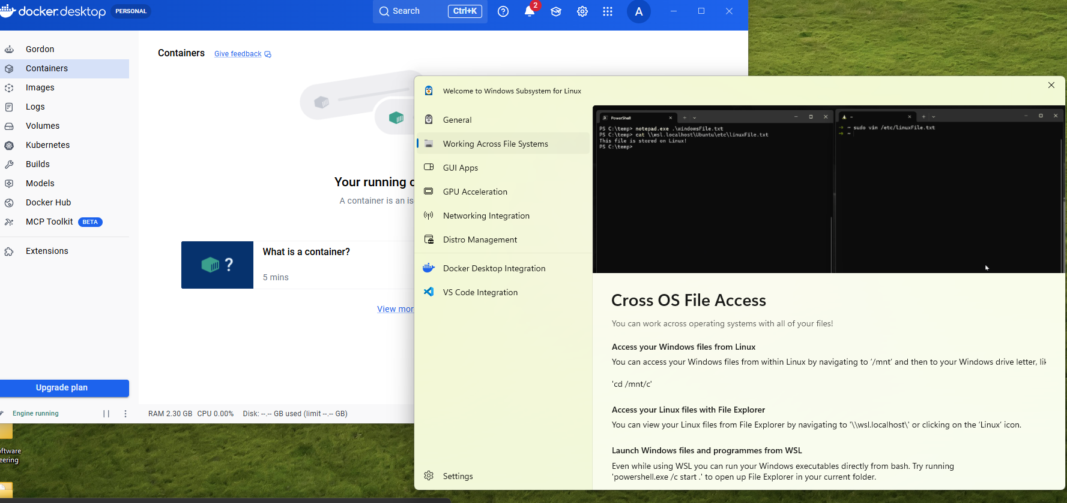
- A basic understanding of the command line interface.
Steps
Here is a step-by-step guide:
1. Create Your Application Files
First, create a new directory for your project and navigate into it using your terminal.
In cmd / bash type
mkdir python-docker-app
cd python-docker-app
a. Create a sample Python application (app.py)
Use a text editor to create a file named app.py with the following content. This simple Flask app will respond to web requests:
from flask import Flask
app = Flask(__name__)

@app.route('/')
def hello():
return 'Hello, Docker! This is a sample Python app.'

if __name__ == '__main__':
app.run(debug=True, host='0.0.0.0')
b. Create a requirements file (requirements.txt)
Create a file named requirements.txt to list the dependencies for your application. This example only uses Flask:
flask
2. Create the Dockerfile
The Dockerfile contains instructions for Docker on how to build the image for your application.
Create a file named Dockerfile (no extension) in your project directory with the following content:
dockerfile
# Use an official Python runtime as a parent image
FROM python:3.9-slim

# Set the working directory in the container
WORKDIR /app

# Copy the requirements file into the container
COPY requirements.txt ./

# Install any needed packages specified in requirements.txt
RUN pip install --no-cache-dir -r requirements.txt

# Copy the rest of the application code into the container
COPY . .

# Make port 3000 available to the world outside this container
EXPOSE 3000

# Define environment variable
ENV NAME World

# Run app.py when the container launches
CMD ["python", "app.py"]
3. Build the Docker Image
First launch the docker desktop app first. Then sign in to it with Github username
Now, use the docker build command to create a Docker image from your Dockerfile. Make sure you are in the same directory as your Dockerfile.
In cmd / bash type
docker build -t my-python-app .
docker build -t your_username/image_name:tag .

- -t my-python-app: Tags your image with a name (my-python-app) so you can easily reference it later.
- .: Tells Docker to look for the Dockerfile in the current directory.
4. Run the Docker Container
Once the build is complete, you can run your application inside a Docker container using the docker run command:
In cmd / bash type
docker run -p 3000:3000 my-python-app
- -p 3000:3000: Maps port 3000 on your local machine to port 3000 inside the container.
5. Verify Your Application
Open your web browser and navigate to http://localhost:3000. You should see the message: "Hello, Docker! This is a sample Python app."
Your Python application is now successfully containerized and running within a Docker container.

Where to Find the Image File
Docker stores images in a specific location on your host system, but it's not a single, easily accessible file like a standard executable. Images are stored in a layered filesystem optimized for storage efficiency and are managed by Docker itself.
- Access via CLI: The best way to "find" your image is to list it using the Docker command-line interface:
In cmd type
docker images

to push to the docker hub
retag to be the same as to the docker file path. If the file path is alanchow85/andy
type
docker images
check the image to rename/retag
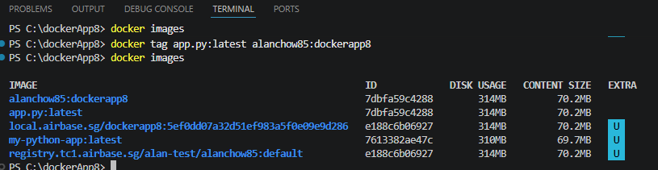
type
docker tag my-python-app:latest alanchow85/andy:Testv2.0
docker tag app.py:latest alanchow85/andy:Testv2.0

then type
docker push alanchow85/andy:Testv2.0

see your image in https://hub.docker.com/repository/docker/alanchow85/andy/general

take note that when u first build the image, it was my-python-app and the :latest means it is the latest

